Terms of rental
- For Members use only. For OSM activities only.
- Handheld use only. No mounting to vehicles.
- Not to be used during rain/precipitation, below 0°C or above 35°C, or during high wind.
- For loss or damage we request that you contribute £50 as a minimum with more on a voluntary basis.
- Late returns will incur a fee of £6.00. Increasing by an additional £6 per week (they also cause an inconvenience for the next hirer).
- On receipt please check that you have all the parts: LG 360 Camera, Cap (squeeze the buttons to slide this off), USB Cable, Micro SD card (inside the camera), Monopole, lens cleaning cloth a return delivery stamps.

Instructions
This LG 360 (LG-R105) camera captures 360 degree images using it’s dual lenses. The battery will be enough for about 2 hours of continuous use, so if you plan a longer session, make sure to think of extra power supply. GPS is not built into the camera, but you can capture geotagged photos by connecting the camera to your smartphone.

With Android or iOS (using the LG 360 app)
Mapillary for Android doesn't have external camera support yet, but it is possible to use the LG 360 Cam Manager app on Android to control the camera and geotag the photos. You need to change the settings in the LG 360 app to capture in interval mode and to record location information. Later, you can upload the photos via the web uploader.
- Using your phones app store download the LG 360 app:
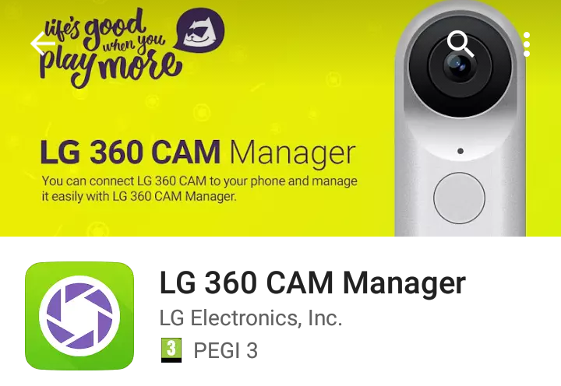
- Turn the LG 360 camera on by pressing and holding the power button (1 second). The lights should start to flash and this will be followed by a sound effect.
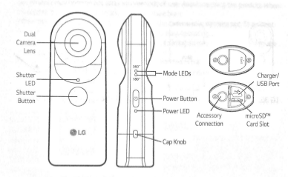
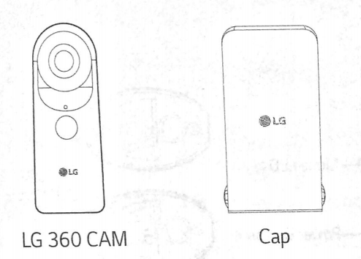
Extracts from the User Guide
- Open the LG 360 CAM Manager app. Connecting to the camera is a two-stage process. First it connects via bluetooth (left image). Once you reach the second screen (right image) click on “Camera” - the app activates the cameras WiFi and re-connects to the camera using WiFi. If prompted for a WiFi password use “00213310” (without quotes).
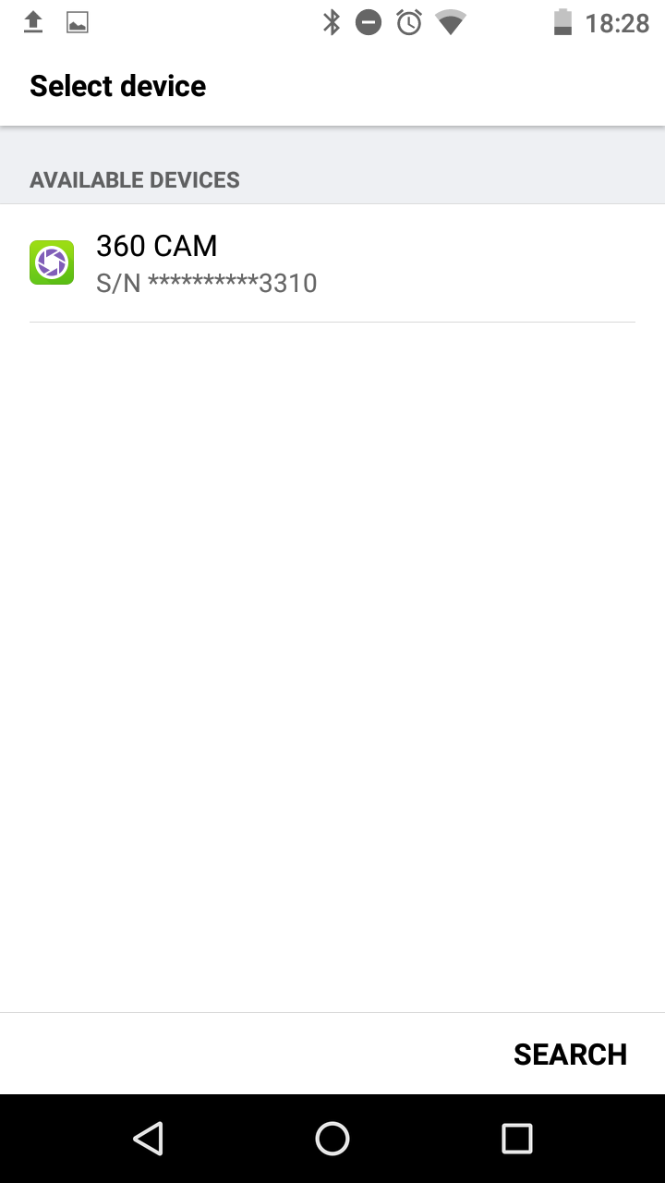
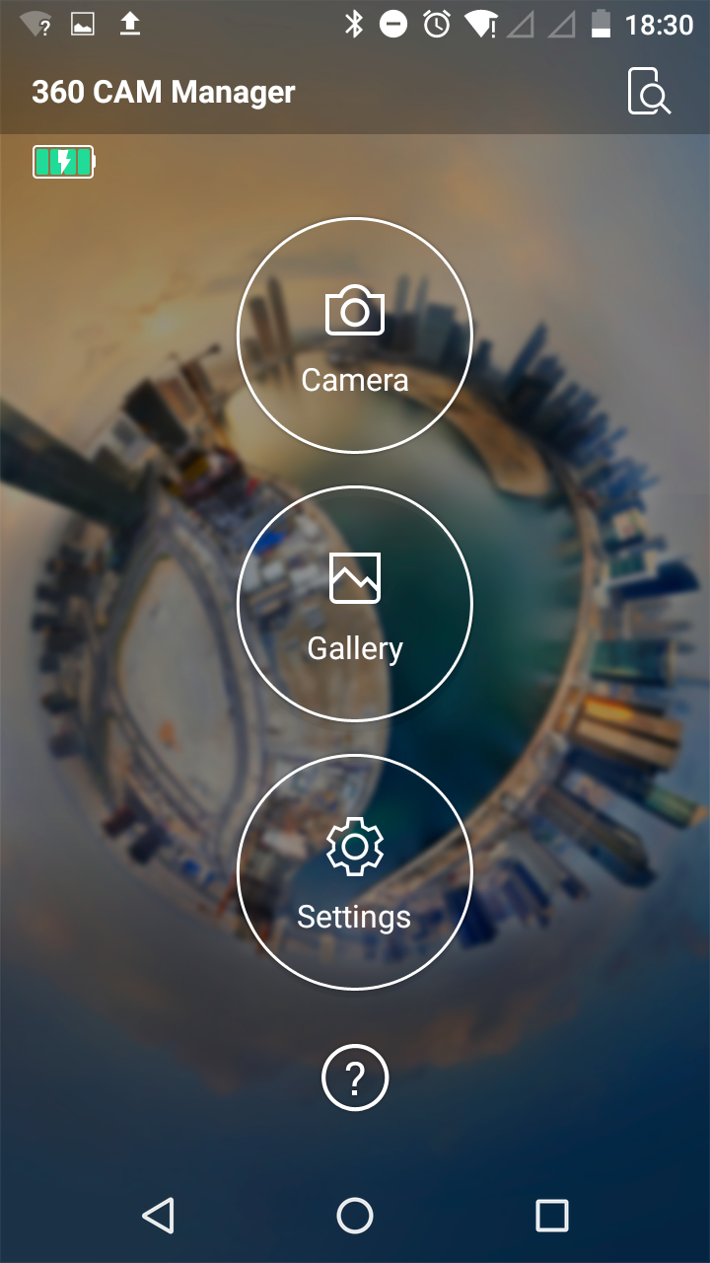
Note: On some phones the app fails to connect via WiFi. If this occurs you can manually switch the camera’s WiFi on by pressing the Power Button and Shutter Button simultaneous twice (at a speed similar to double clicking a mouse – when successful blue lights will flash and a sound effect is heard). On your phone connect to the WiFi “LGR105_213310.OSC” using password “00213310” (via the phone’s wifi settings menu) – the camera will beep to confirm it is connected. When this occurs head back to the LG app and click “Camera”.
- Click on the cog wheel and check that the GPS location is switched on (as shown on the left image). Next click MODE and “timed continuous shoot” mode (the camera and clock icon as highlighted on the right image). We suggest selecting either a 2 second or a 5 second interval.
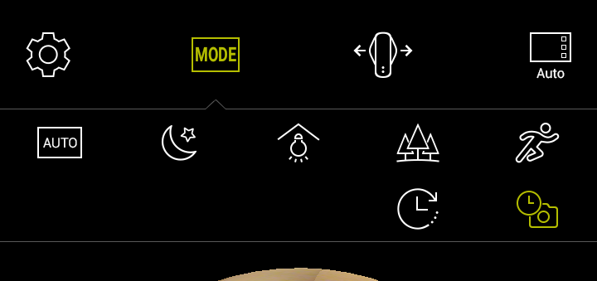
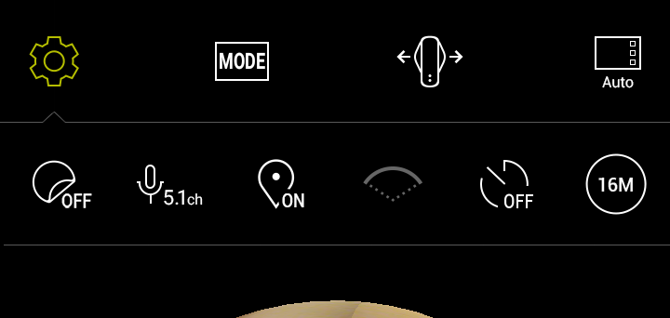
- You are now ready to start a photo walk. Holding the camera above you head, press the shutter button on the LG app (the camera icon). A photo will be taken every X seconds according to the option you selected above. To stop taking photos press the square stop button on the LG app.
- When finished, connect the camera to a computer using the USB cable an copy the photos to your computer hard drive.
- In a web browser, navigate to https://www.mapillary.com/app/uploader to upload your images. You will need a Mapillary account.

With iOS (using the Mapillary app)
The Mapillary app for iOS supports connecting to the LG 360 Cam so that you can use the Mapillary app to easily capture and upload photos. It also makes sure that capture is automatically paused when you stop moving for some reason. Images are transferred to the phone and you can review, delete, and upload them as regular sequences in the app.
- Start with clearing the camera’s memory card (we suggest you do this before each Mapillary session).
- Pair the camera and your phone. You will need the LG 360 Cam app because that's where you enable WiFi on the camera (alternatively you can switch on the camera’s WiFi by double clicking the Shutter and Power buttons as described above).
- Change to your 360 camera’s WiFi on your phone (WiFi: “LGR105_213310.OSC” password: “00213310”).
- Go to the camera screen in the Mapillary app and tap on the WiFi button to search for and connect to the external camera.
- Capture as usual. The app will control the 360 camera to capture every 1-8 seconds (you can change this in Settings).
- Transfer the images from the camera to your phone directly after the capture (you will be prompted for this) or do it from the Uploads view later.
- Review and upload as usual. Note that the images are saved on the memory card in the 360 camera until you delete them yourself.

Battery and power
- It takes approximately 2 hours to charge the LG camera. Use power plug from a mobile phone/tablet or plug into a USB port on your computer.
- The Power LED on the LG 360 camera indicates the batter status. Green = More than 15%, Red = 5-15%, and Red blinking = Less than 5%.
- Powering on and off:
Power On | Press and hold the Power Button (1 Second)
Power Off | Press and hold the Power Button (4 Seconds or longer)
Enter Sleep Mode | Press and hold the Power Button (1 Second)
Exit Sleep Mode | Press and Power Button
Forced Shutdown | Press and hold the Power Button (12 Seconds or longer)

Returning the camera
You will find a sticky label and pre-paid postage in the parcel. Unless you have been provided with an alternate address, please return the camera to:
R Nickerson
67 Birch Meadow Close
Warwick
CV34 4TZ
Please check that all the parts are included and that they are suitable packaged.
- LG 360 Camera and Cap
- USB Cable
- Micro SD card (inside the camera)
- Monopole
- Lens cleaning cloth.
- These instructions

So that we can get the camera back and sent to the next person in time, please ensure that you put the camera in the post on or before the date below.

Latest return postage date:

___________________________________________________

If you have any questions or concerns please contact board@osmuk.org or phone Rob on 01926 656446 (forwards to mobile).

